Stat:
- LR+:
- Sen/1-Sep (LR+)
- The distance between the upper and lower boxes:
- Interquartile range
- Means of outcome measure
- 95% CI
- 1-Sen/Sep (LR-)
- True positive/True Positivity + False Negative (sensitivity)
- True negative/ true negative + false negative (NPV)
- Greater variance for age-standardized rates for females
- Great difference for both bet 1990 – 2021
- Correlation: Weak positive
- SPMM: Based on publicly accessible data, the following graph shows the extent of variation in planned spending by clinical commissioning group on child and youth mental health, according to the index of multiple deprivation (IMD). [BMJ 2017;356:j451]. Which commissioning group in this figure demonstrates that there is a "postcode lottery" for receiving mental health services for children and youth? Bradford
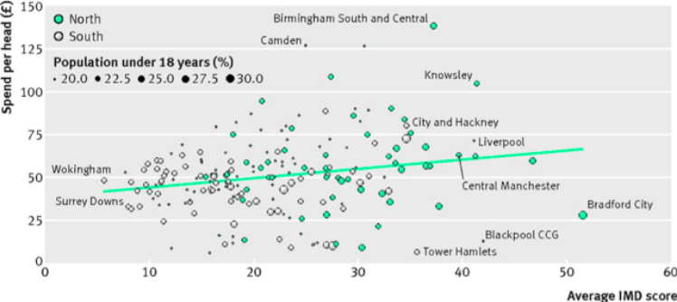
- ARR (Forest Plot- lithium) events and total, what was the combined risk difference (Lithium and placebo relapse rate)
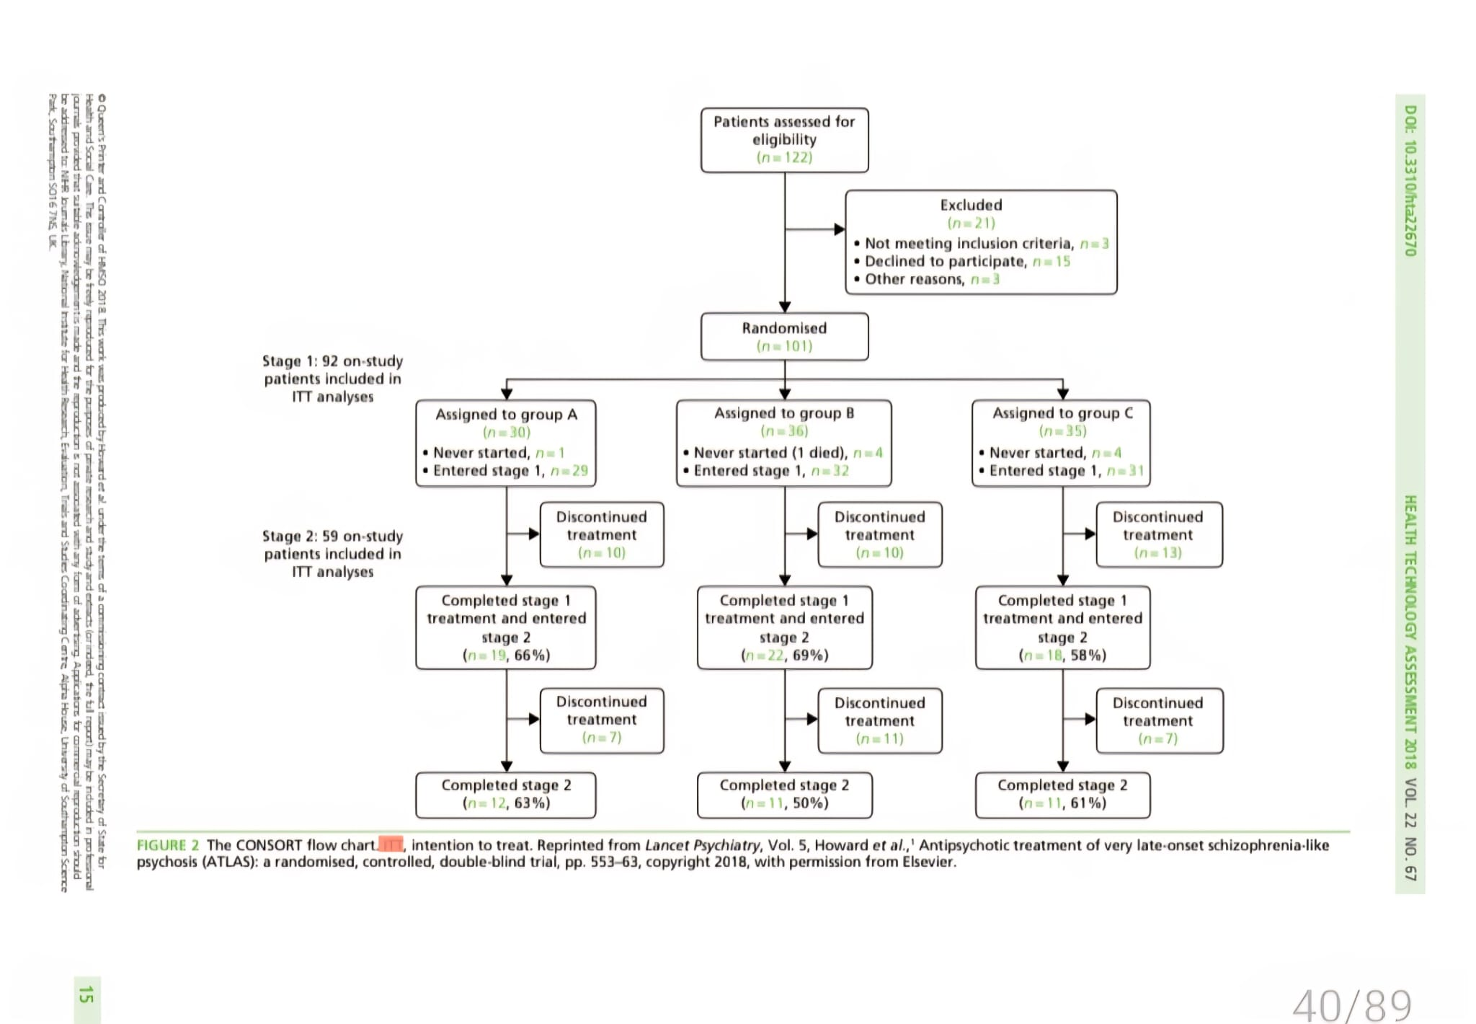
- Attrition rate by the end of stage 1, ITT analysis: 59/101
- The number of patients that started stage 1, whether they took the medications or not, in all the placebo and amisulpride groups: 91
- Venlafaxine has an OR=1
- Equal
- No difference
- Comparator
- Cardiac events for the antidepressant
- No statistically significant results for all the antidepressants
- Which of these would be the least confounding, the table was adjusted for age and sex

- Alcohol
- Smoking
- Cholesterol
- Severity of depression
- Age

- Study about the MET and regular care (Key worker) for patients with alcohol abstinence, and the outcome measures were bet the first alcohol drinking and the severity of harmful drinking. Which confounder needs to be adjusted for?
- Visits to A&E
- Key worker's view about MET
- Co-substance misuse

- Meta-analysis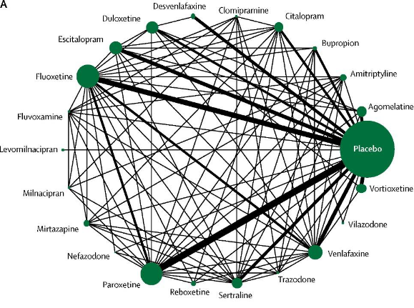
- What does the line represent?
- Size of the RCT
- Number of participants in RCTs
- Number of individual studies bet the 2
- Weight of the pair of study
- Confidence interval
- Which one was significant? Age, Type, after 6 months with depression and mania, 6 months, Family history of substance misuse
- One assumption about ANOVA
- The date needs to be linear
- The variance needs to be equal
- The mean is to be equal
- The variance needs to be interdependent
- Test of the association between BP and height, controlling for weight
- Chi Square
- ? Regression
- Pair t-test
- Dementia tests had sensitivity and specificity for 7 tests
How many patients need to be screened for 250 patients to be identified with dementia for the clock test Sensitivity was 59%
- The test with the least False Negative
The mini cog 76%
Clock test 59%
MMSE (23/24)
MMSE (24/25) 79%
Battery
- NNT effect size for 80% and 30%
- Variance coefficient (What F stands for)
- Ratio
- Unadjusted effect size
- Adjusted effect size
- Standard error
- Cost-utility
- Quality of life
- Correlation (Non-parametric) ECT 13000, 7000 had ECT, then 3000 of them had a stroke then an ECT. What test is used to measure (…..) on ECT.
- Inter Class
- Kendall
- Chi square
- Having an independent reading of the reviews and the outcomes
- Triangulation
- Bayesian and frequentist theories
- The Bayesian reviews the probability and continues to update
- Frequentist is more reliable than Bayesian
- Doctor wants to do a systematic review, which reporting body should he use
- PRISMA
- CONSORT
- MOOSE
- How would they know they have collected the right sample
- Data saturation
- Homoscedasticity Means
- Variables being similar
- CAGE and the cut off increased from 2 to 3, what would happen
- Sensitivity decreasing
- Sensitivity increase
- Specificity Decrease
- No longer valid
- The ASD questionnaire can detect asd symptoms, gives no symptoms for ADHD
- Divergent validity
- Suicidal test, can say pts would attempt self-harm in the future \
- Predictive validity
- New scale for PTSD that matches the old scale
- Concurrent validity
- Diagnostic purity bias and how to decrease
- Recruiting patients from the hospital for more homogeneous data
- Include non-severe cases and atypical cases
- Include only severe cases
- Spectrum Bias
- To test for heterogeneity
- I² statistics
- Cochrane Q
- Degree of freedom
- (Meta analysis)
- (Sensitivity analysis)
- Analysis
- Susser criteria (Most essential)
- Time order
- Predictive performance
- Specificity
- Strength
- Consistency
- Depression scale with Loneliness scale, depression score was the outcome measure. 0.38 (P: 0.04)
- Every extra point in loneliness leads to an increase of 0.38 in depression.
- Every extra point in depression leads to an increase of 0.38 in Loneliness
- Every extra point in loneliness leads to a decrease of 0.38 in depression.
- Every extra point in depression leads to a decrease of 0.38 in Loneliness
- Test for Chi Square
- Test for Paired T test

- Equal Prevalence Male to Female
- Hypochondriasis
- Unipolar
- GAD
- PTSD
- Antidepressant induced manic symptoms, started on Olanzapine, were stable. Then stop because of weight. Came to you with mild to moderate depressive symptoms, what do you give them
- Lithium
- Lamotrigine
- Olazapine
- Quetiapine
- Fluoxetine
- Highest heritability
- Schizophrenia
- MDD
- GAD
- PD
- Caution with Clopzaine
- Neurofibromatosis
- Tuberculosis
- Narrow-angle glaucoma
- GERD
- A drug that you need to reduce the ECT dose
- Lofepramine
- Venlafaxine
- Moclobemide
- The man came to A&E with a sudden onset of Aphonia after his mother-in-law moved in. Law, move it permanently
- Dissociative Motor Disorder
- Dissociative Neurological disorder
- Body distress disorder
- Acute stress reaction
- 31 years 31-year-old patient after having an accident 2 weeks ago, now he is reporting symptoms of anxiety and no unable to get in cars.
- EMDR
- Active monitoring
- CBT- trauma-focused
- Best predictive test for traumatic brain injury
- PTA
- Duration of unconsciousness
- Duration of retrograde amnesia
- GCS scale upon presentation
- In Bipolar affective disorder, between Men and women, which one is more likely to be diagnosed with the diagnosis
- Men have a higher prevalence of attempted suicide
- First presentation in Men is hypomania
- Men diagnosed with Bipolar II
- Rapid cycling
- Depo that needs a Test dose
- Haloperidol
- Risperidone
- Olanzapine
- Paliperidone
- Flupentixol
- Inner restlessness (EMI)
- Propranolol
- Procyclidine
- Tetropenazine
- Movement of mouth, lips and trunk
- Tetraenazine
- Weight gain
- Metformin
- The patient is worried about the weight gain
- Risperidone
- Flupentixol
- Quetiapine
- Haloperidol
- Olanzapine
- Prevalence of Postpartum depression
- 11-15
- 16-20
- Pt with formal thought disorder, Bizarre behaviour, what test would be affected
- Sally Anne
- Selective attention
- Digit span
- Complex cards
- Lady gave birth 1 year ago, reporting intrusive thoughts of harming the baby, distressing and tearful, doesn’t want to act on these thoughts, reporting the birth to be traumatic.
- OCD
- PTSD
- Psychosis
- Alzheimer
- PD
- Friedreich's ataxia
- Multiple Leuco.
- UMN Gait
- Scissoring
- Parkinson’s pt, citalopram and levodopa, symptoms are managed well, MMSE was 21/30, no sleeping, hallucinations, what would be the best option
- Rivastigmine
- Memantine
- Risperidone
- Olanzapine
- Alzheimer's is aggressive despite intervention
- Risperidone
- Paradoxical injunction
- Systemic
- Family past
- Psychodynamic
- Non-spoken roles
- Structural
- ECG, Lady on Donpezel, ankle swelling, fatigue, seizure.
- QTC prologation
- Bradycardia
- Low voltage QRS
- ST depression
- ECG ED purging, using laxative
- ECG Clozapine (Myocarditis)
- ED, What changes in bloods
- Hyperkalemia
- Hyperphosphatemia
- Increase creatinine
- Hypercholesterolemia
- Lady fainted, has been on Deluxitine, recently took diphenhydramine, what an ECG
QTC prolongation
- AN pt, when will you consider admission to hospital
- SUSS
- 50 -60 HR
- Psychosis.
- Self-harm behaviour
- Unable to get up from bed
- Mephdron, class
- Opioid
- Hallucinogens
- Stimulant
- Depressants
- Consultant presses on the lips, where is the injury
- Frontal lobe
- Priatal
- Non-demina Partial Lobe
- Anosognosia
- Drug with life-threatening Withdrawal
- Methamphetamine
- Nitric Oxide
- Opioid
- Psychosis with PD with a drug that has most best evidence, antipsychotics
- Clozapine
- Rivastigmine
- Quetiapine
- Withdrawal (Vivid dreams, hunger, fatigue, dysthymia)
- Cocaine
- 74, what would lean towards dementia, not ageing
- Forgetting the day, then remembering after a while
- Concentrate more on the conversation
- Delayed reaction
- Changes to activity, then fixated, then irritable
- Misinterpret the shadows and people
- The most sensitive test to differentiate dementia from MCI
- MMSE
- MRI
- Informant daily activity assessment
- Information cognitive
- MOCA
- Similar prevalence of ED gets higher prevalence when it has ASD as a comorbidity
- ARDIF
- Rumination disorder
- PICA
- Binge Eating
- What eating disorder better prognosis with adolescent onset than adult
- AN
- ARDIF
- Rumination disorder
- PICA
- Binge Eating
- Eating disorder with the same prevalence in low, middle and higher socioeconomic groups but increases with increasing BMI in society.
- AN
- ARDIF
- Rumination disorder
- PICA
- Binge Eating
- Higher comorbidity with Bipolar disorder in CAMHS
- Anxiety
- ADHD
- PTSD
- OCD
- Social Anxiety in adolescents, higher comorbidity in adults
- OCD
- Substance misuse
- Schizoid PD
- Woman in safe housing because she had a violent ex-husband
- Article 3
- Detainee asking to speak to a judge and to have a tribunal
- Article 5
- Mental health Detainee, sent to prison because there were no beds.
- Article
- How many years do people with LD and ASD die before the rest of the population
- 10
- 20
- 30
- 40
- CAMHS depression on Fluoxetine, not improving, moderate depression with suicidal ideation, what is next
- Sertraline
- Escitalopram
- Venlafaxine
- Mirtazapine
- Research in LD
- They need to know that they can withdraw consent whenever.
- LD patients can’t consent
- LD, if it is not written, can’t consent
- Family or guardians are only able to consent
- Bourne article
- Snags, dillimas, traps, which therapy
- CBT
- DBT
- CAT
- Psychodynamic Psychotherapy
- Rational emotive behavioural therapy.
- At-risk mental state has CBT
- Indicated
- Program to reduce violence and antisocial behaviours in schools and preschools for deprived families and their children.
- Selective
- A program in school to reduce smoking cigarettes.
- Universal
- How to reduce the consumption of alcohol in the community
- Increase the price per alcohol unit
- Improve the knowledge
- Test for Korsakoff syndrome
- Digit span
- Address recall
- Sleep apnea and risk-related
- Euresis
- Coperasis
- Aniexty
- BN
- ADHD
- Binge eating
- ASD
- Institutionalised kids
- Conduct
- Reactive attachment disorder
- AD TS
- AR Phenylketonuria
- X-linked R Lesh nehan Disorder
- X-linked D Fragile X
- Huntigton Diagnosis
- 26 CAG
- MRI with atrophy of the head of the caudate nucleus
- Simple motor tics
- Grimacing
- Touching
- Hopping
- Which Dementia would improve/reversible
- Alcohol dementia
- Mentioned a few symptoms of FTD, then asked about the type of aphasia in this disorder
- Non-fluent aphasia
- Unfit to plead
- Severe thought disorder
- Amnesia
- Delusions
- QTC 490, risperidone and citalopram. What is the next step
- Reduce the dose of Risperidone
- Why attempting UDS
- Treatment effectiveness
- To know if the patient is taking Novel drugs
- Moderate LD
- > 70
- 69 – 50
- 49 – 35
- <20
- Disulfiram contraindication
- Cardiac failure
- Epilepsy
- Chronic use of Ketamine
- Cystitis
- Liver failure
- Renal failure
- Hierarchy in anxiety
- Systematic desensitization
- Diminished responsibility can be included in which
- Rape
- Theft
- Murder
- Differentiate Night terror from nightmares
- Doesn’t recall the event
- Behavioral activation
- The degree of avoidance
- The reason for the case series
- To report rare events
- Hitting, shouting, punishment, domination
- Coarse control
- A 40-year-old woman, intact orientation to time place person who has difficulties with her memory, is unable to make new memories, according to icd 11 what is the diagnosis
- Amnesia disorders
- MCI
- Mild neurocognitive disorder
- Risk of velveteen in mothers
- ASD
- ADHD
- Risk with streptococcal
- OCD
- Paroxetine continued throughout pregnancy: What is common to see
- Irritability
- Persistent pulmonary hypertension
- ECT improvement in TRD
- 85%
- 65%
- Pt is shouting at the doctor, saying, where were you when I was young
- Externalization
- Free Association
- Negative therapeutic effect
- Transference
- Pt says everyone around me is depressed, but she says that she is happy.
- Deniel
- Externalization
- Transference
- Pt is on Methadone 5mg, wants to start something to continue his abstinence after stopping the methadone
-Naloxone
Naltrexone
Buprenorphine
- Head injury in children
- Mood disorders
- ASD
- MCP23
- Rett syndrome
- Prevalence between males and females is equal
- Prada Willi
- What would prevent further recidivism in first-time incident exposure
- Appear in court
- First-line treatment in AN in 12 year 12-year-old
- FT-AN
- Difference bet AN and BN
- Bulimia has more prevalence than AN
- Test ANCOVA (Adjusting for Age) anorexia in 3 groups
- Security in forensic
- Pharmacology
- Procedural, physical, and relational
- An ADHD child with liver disease. Trialed stimulant, what is next? The parent doesn’t want sedative medication
- Guanfacine
- The patient was planning to stop smoking in a month
- Preparation
- Pt heroin again after a week of abstinence
- Relapse

